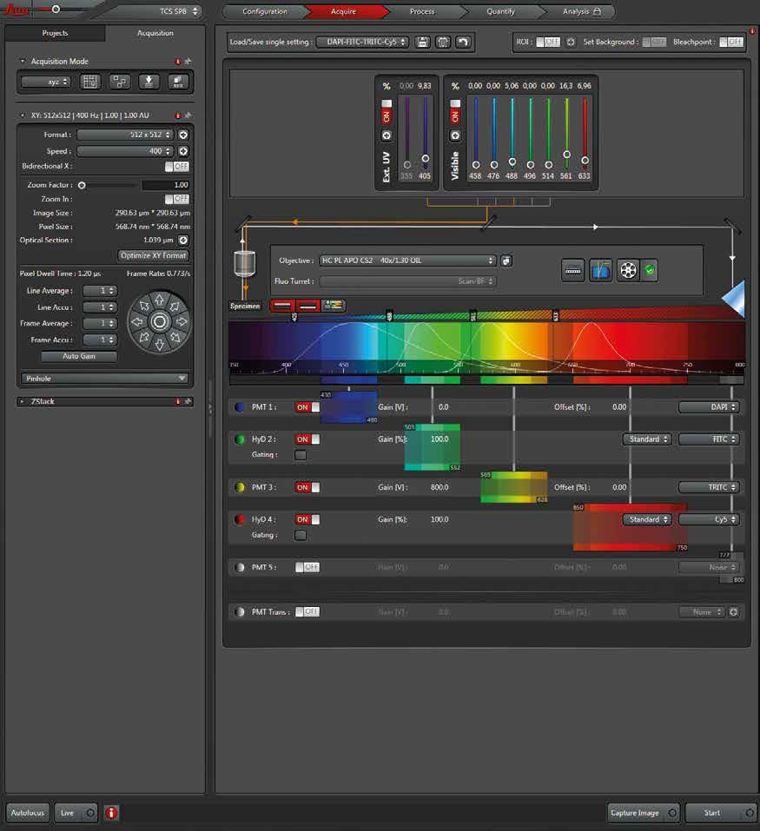

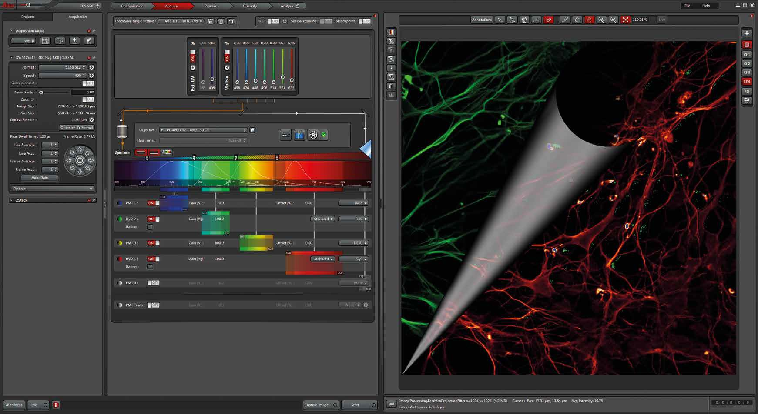

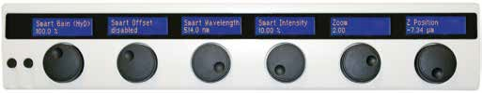

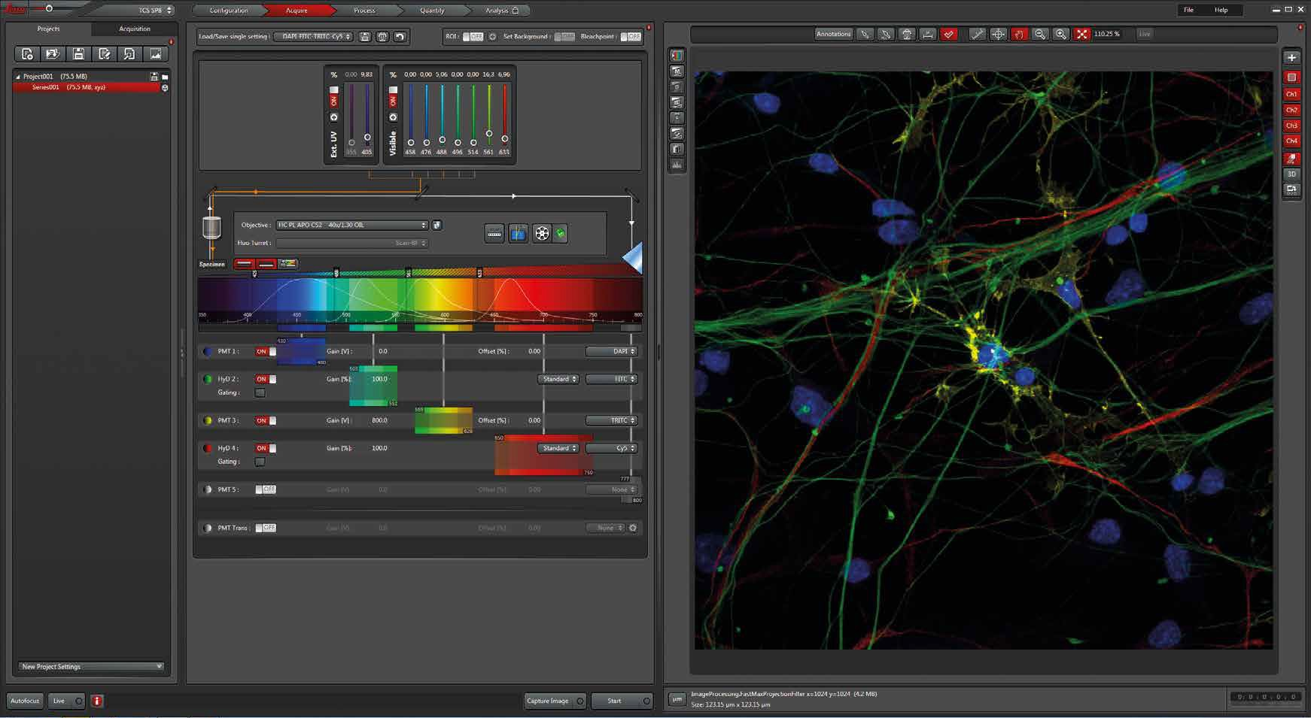

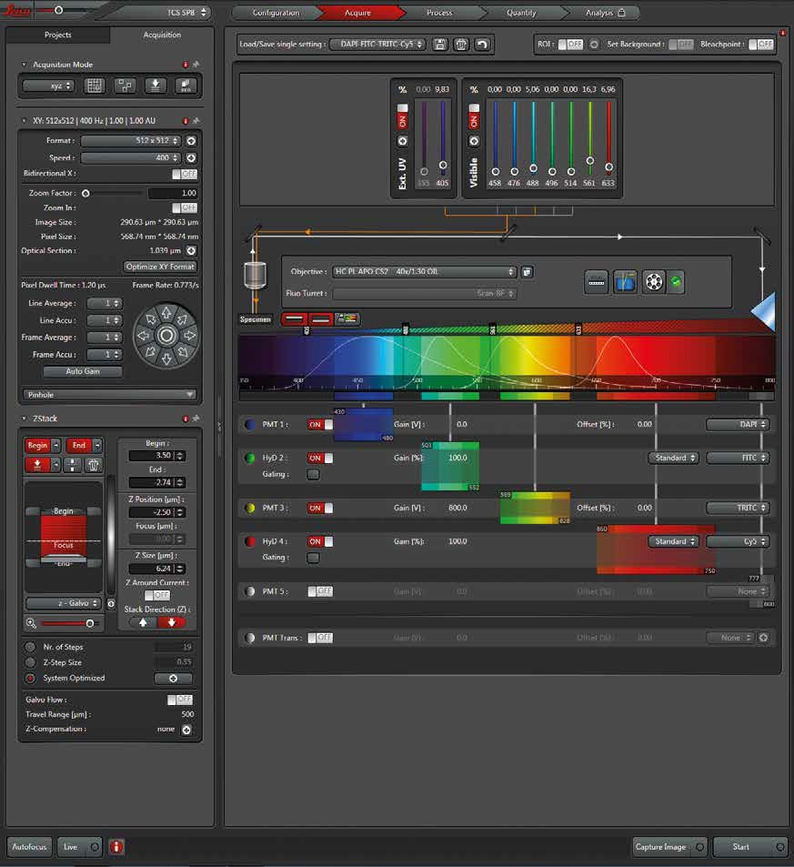

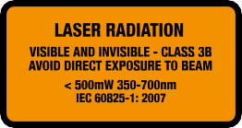
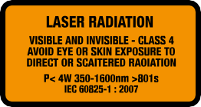
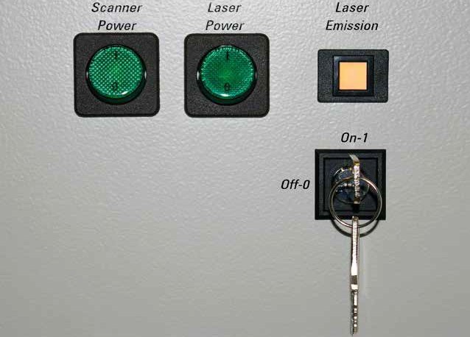
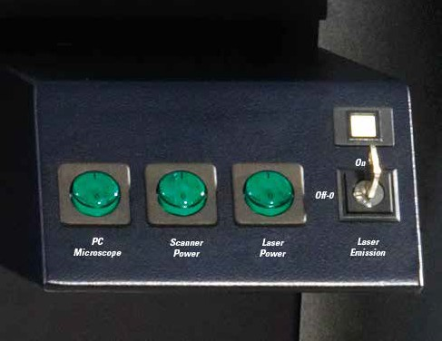
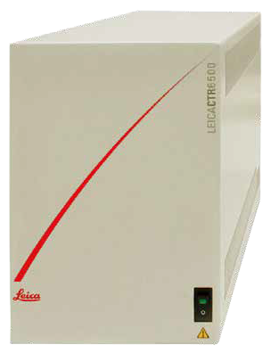
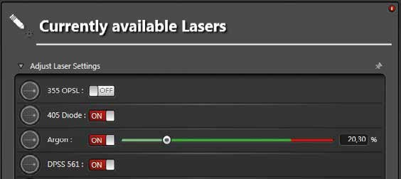
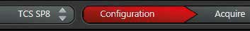
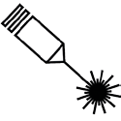
Image Acquisition
Go to Acquire
1
1
2
Choose a single setting from the list (i.e. FITC/TRITC) and continue with step 6.
Steps 2 to 5 are automatically set.
7
6
7
3
5
If no appropriate single setting is available, proceed manually with steps 2 to 5 :
Start Live scan*.
Click QLUT to switch to Glow.
Change Z Position by turning
the respective wheel on the control panel until you get the brightest signal (focal plane).

8
2
4
3
4
Activate lasers (ON).
Set excitation laser line(s). Activate PMT/HyD (ON), defne Gain and Offset.
5 Position PMT slider at
maximum emission.
8
6
8
Optimize image settings manually by adjusting steps
3 to 5 , until the image contains a few blue (saturated) pixels.
Go back to original LUT 7
by clicking twice.
Capture Image*.
Save Project (see below, Z-Series Acquisition).
Z-Series Acquisition
1
2
3
4
Open Z-Stack Dialog. Set Focal Plane.
Set Begin- and End-Position. Click System Optimized to defne the number of slices.
Click Start to acquire the z-series*.
7
8
6

7
6
Click Max. to generate a maximum projection.
To save the experiment go to tab Project and
8 click on Save.
5
1
3
2
4
5
System Shut Down
Follow exactly the sequence described to shut down the system:
1. Deactivate all lasers in the laser confguration window (see Laser Start Up section), wait approx. 5 min. until ventilation of Argon laser has shut-off. 2.
3. Shut down PC.
4. Shut down CSU or FSU, respectively, in reverse order (see System Start Up section).
* CAUTION!
Laser light in objective plane from now on. User manual must be strictly observed.
System Start Up
1
2
3
1 2
3
4
Compact Supply Unit (CSU)
Flexible Supply Unit (FSU)
Turn on the microscope control box.
For system confguration with CSU: Turn on the PC and await the booting process. Then turn on the power supply for the scanner 1 and the lasers 2 by pushing the green buttons and turn the
laser key 3 , to open the laser shutter.
For system confguration with FSU: Turn on the power supply for the PC 1 , the scanner 2 and the lasers 3
by pushing the green buttons and turn the laser key 4 , to open the
laser shutter.
Laser Start Up
1
2
Go to
Configu-ration.
- Activate lasers (ON)
- Use the slider to set the laser power of the Argon laser (458 nm–514 nm) to 20–30 %.

QUICK START – LEICA TCS SP8
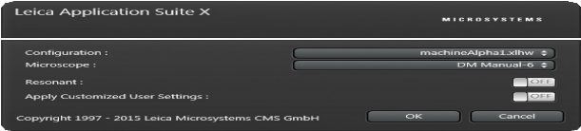


Software Start Up
Start LAS X
by double-clicking the LAS X icon.
Make sure there is the correct selection for Confguration and Microscope.
Turn on Apply Customized User Settings to choose User Settings saved in a preceding session. Turn off Apply Customized User Settings to start LAS X with the default settings. Click OK and follow the instructions (i.e. Initialize Stage).

