CARVER CENTER FOR IMAGING
Leica SP8 confocal microscope is equipped with the following items:
- Okolab stage-top incubator for live cell imaging
- 40x W (water immersion) lens with motorized correction collar.

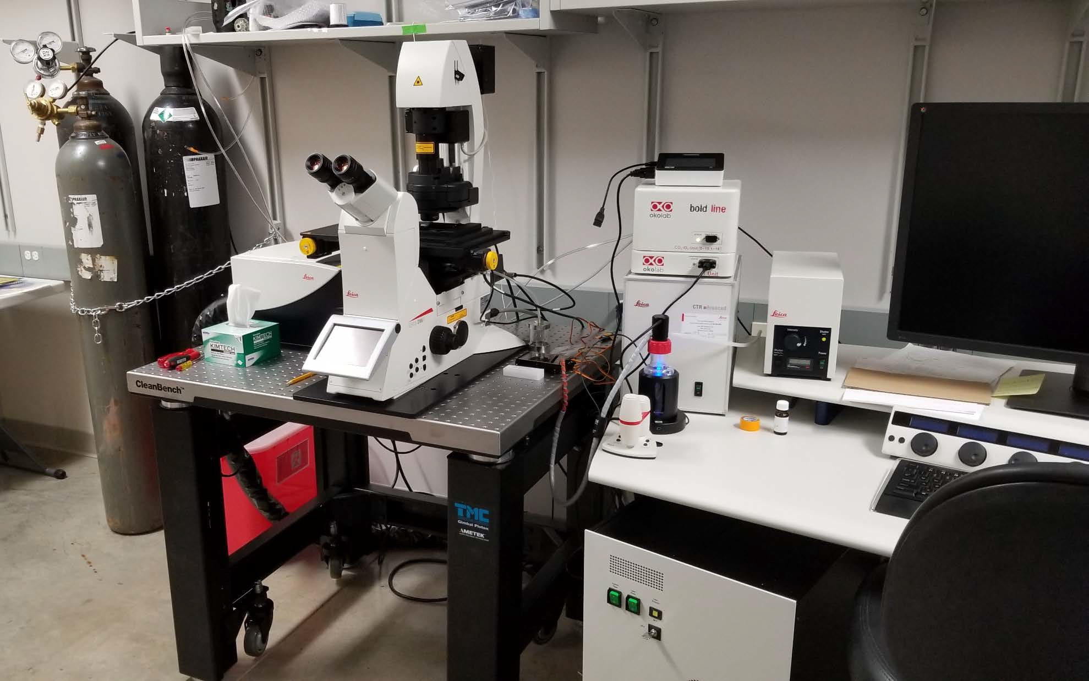






#1) New OkoLab stage-top incubator for live cell
imaging on Leica SP8 confocal microscope

http://www.oko-lab.com/live-cell-imaging/stage-top-digital-gas

Tanks for:
- N2 – to float table
- CO2 – for incubator (normoxia)
- N2 – for incubator (hypoxia)

- Touch pad controller
- O2/CO2 controller
- Temperature controller

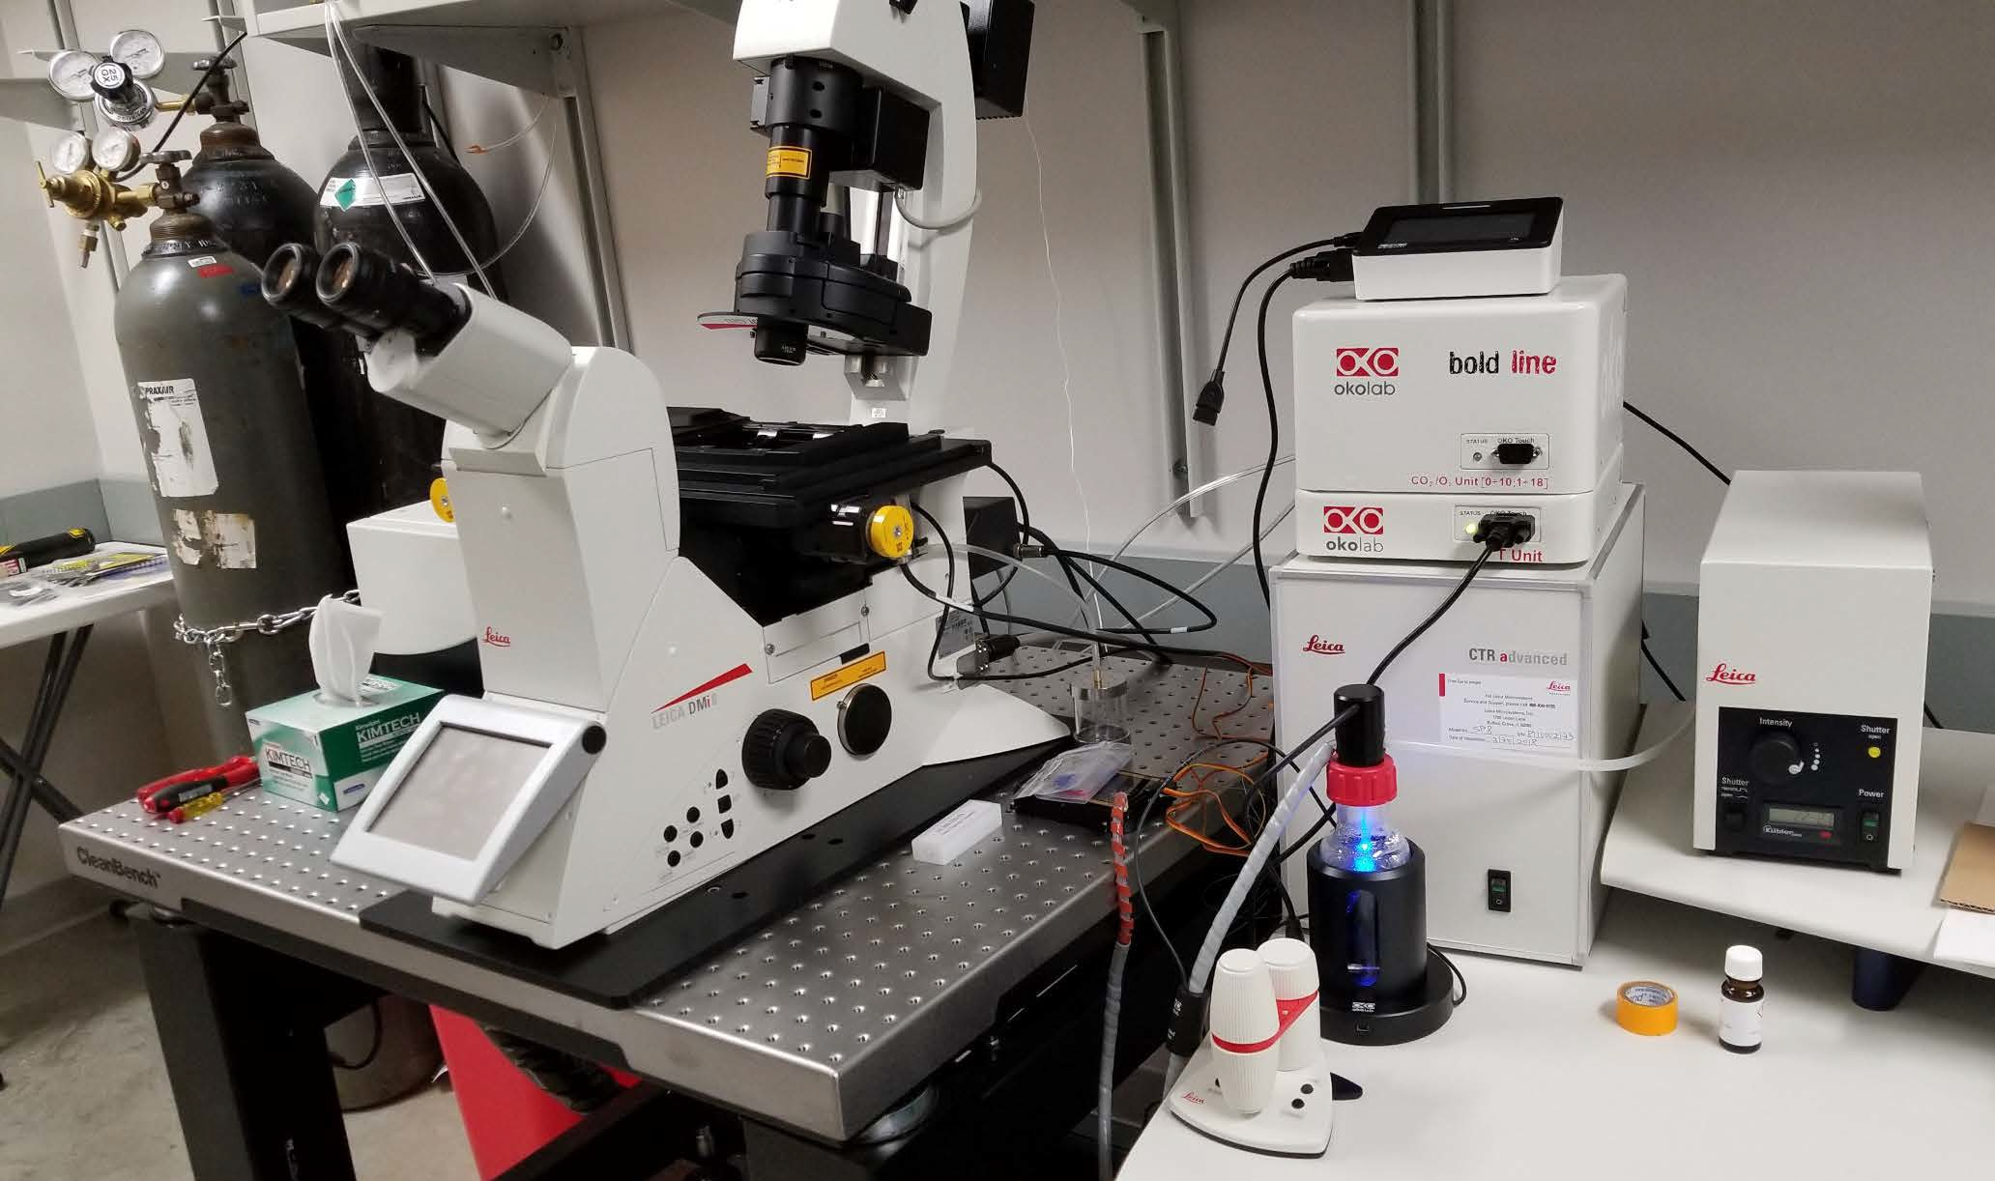


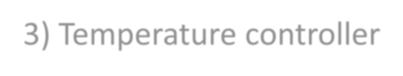



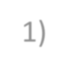
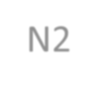


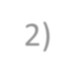
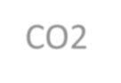



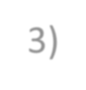



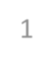
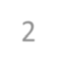
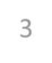

1

2

3

Incubation
Humidifying bubbler
/chamber

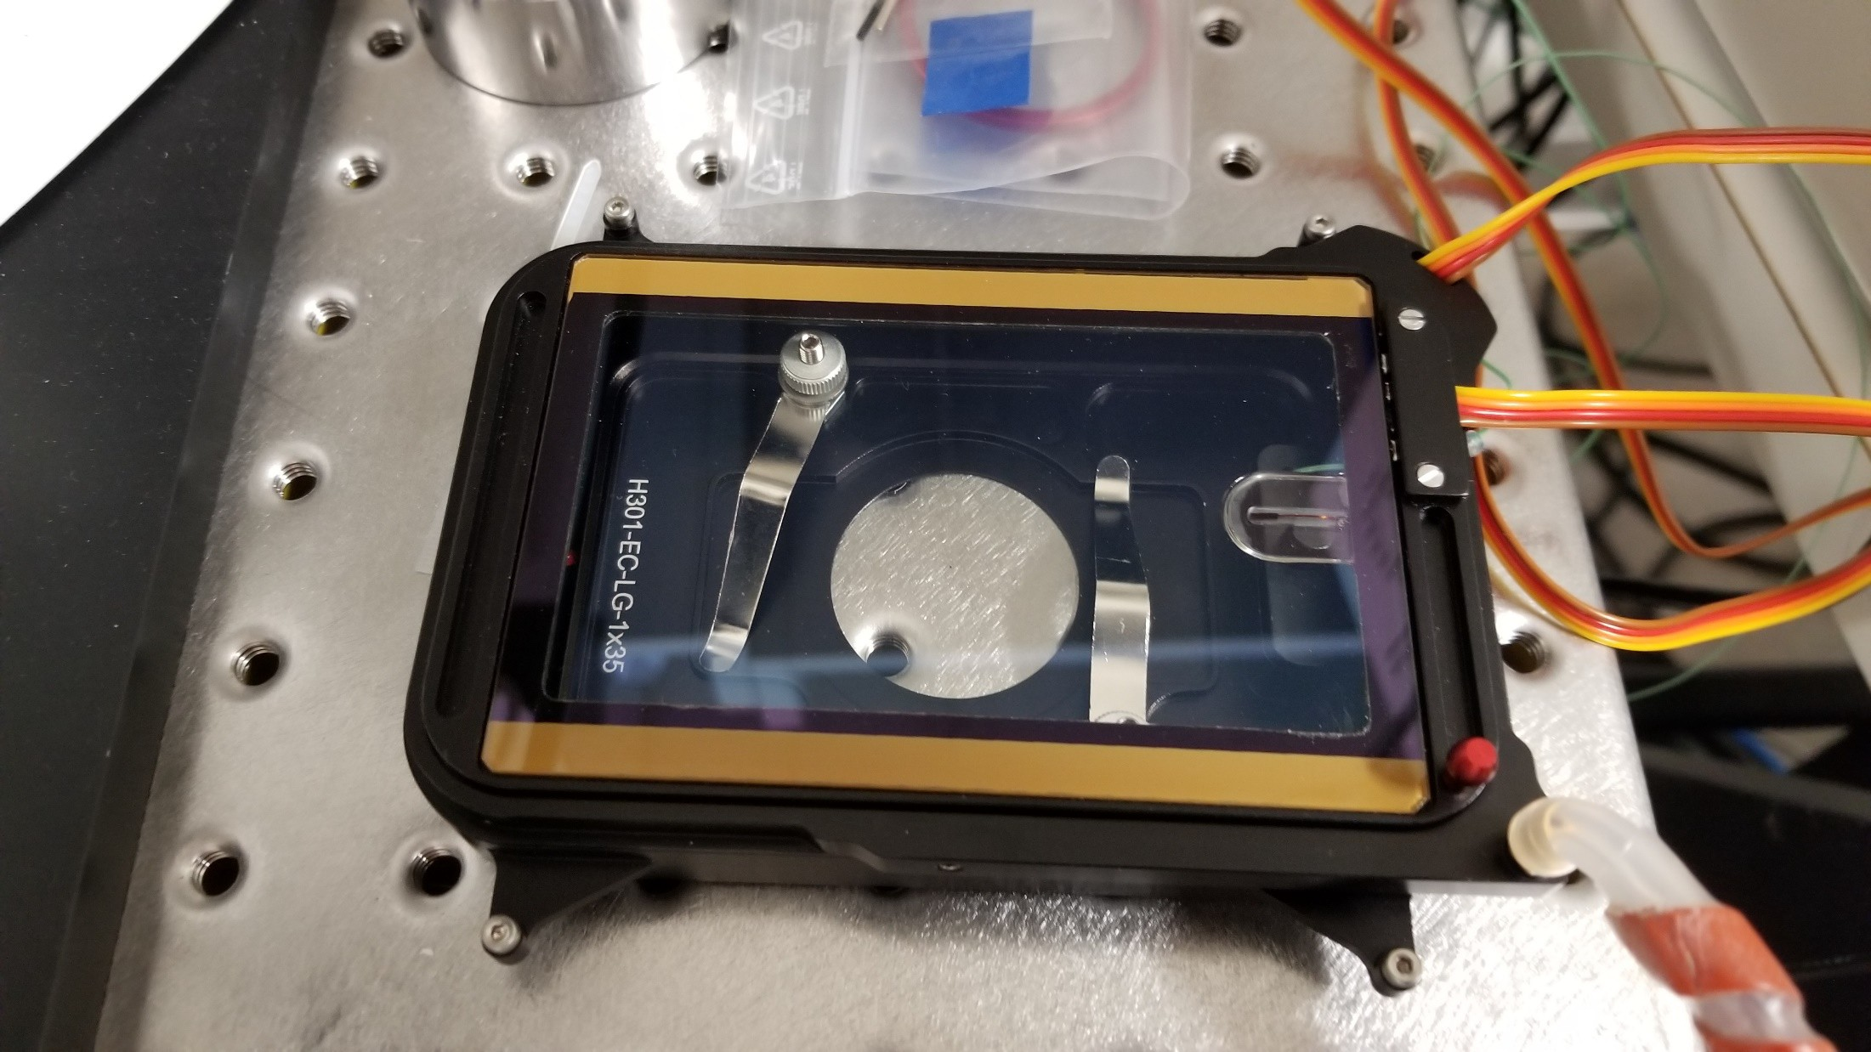






New OkoLab stage-top incubator for live cell
imaging on Leica SP8 confocal microscope

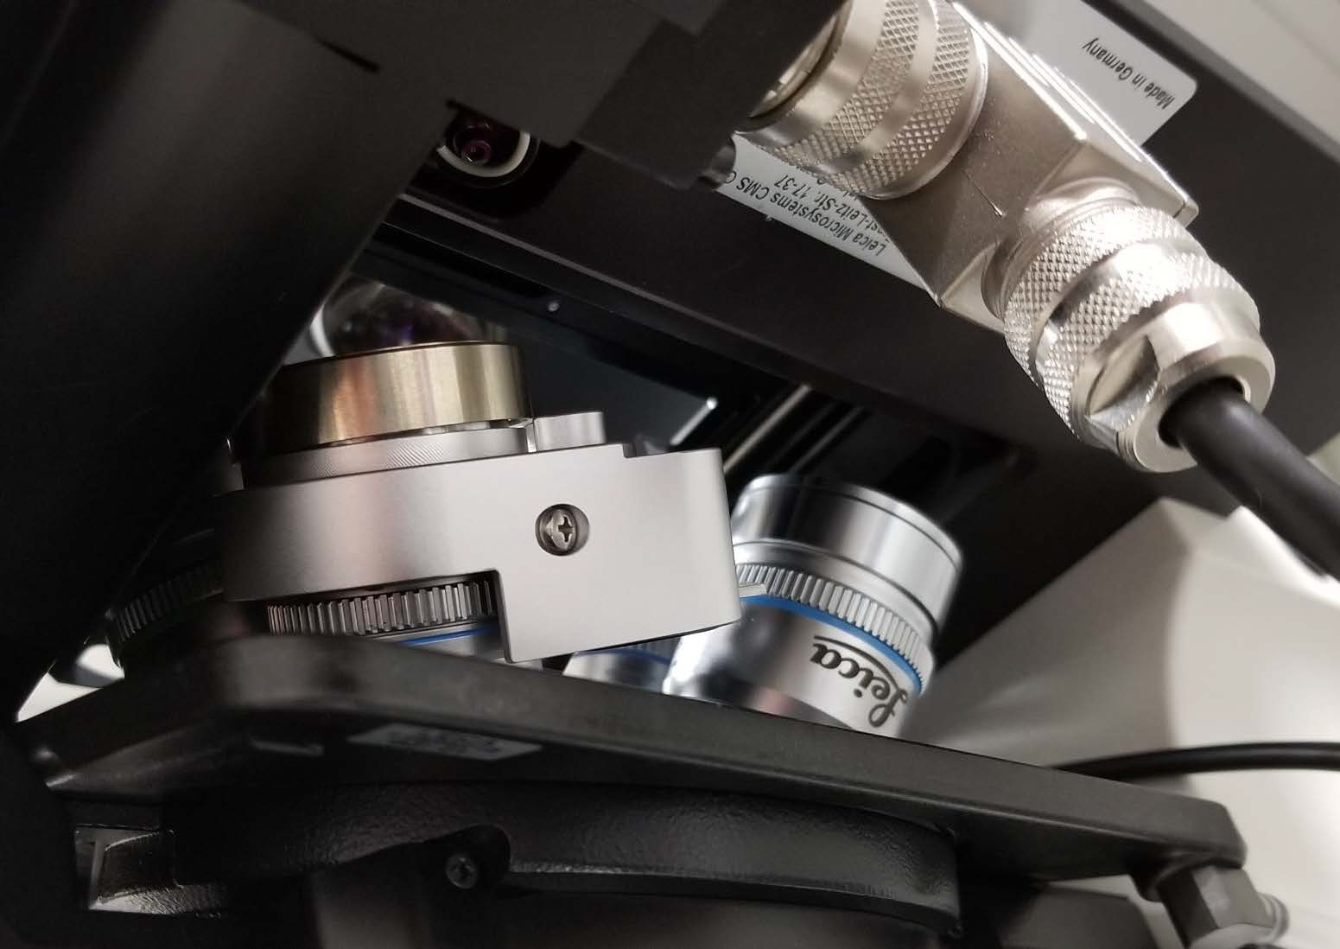

#2) New 40 W mot installed on Leica SP8 confocal

This new water immersion 40x lens has an adjustable, motorized collar to maximize resolution. For details, see link below.

Note that a wire connector restricts turning of the objective turret.

Please see: https://www.leica-microsystems.com/fileadmin/downloads/Leica%20TCS%20SP5%20II/Brochures/Leica%20mot Corr-Flyer_EN.pdf

